Revolutionizing the Board of Veterans’ Appeals – Improving Access and Outcomes
July 2022

Legacy Resolution Prioritization
The Department is keeping its promise to advocate for Veterans – resolving Veterans Legacy Appeals from more than 472,000 pending appeals in late 2017 to 98,000 as of July 2022.
There are currently only 68,000 legacy appeals pending at Board of Veterans’ Appeals (Board).

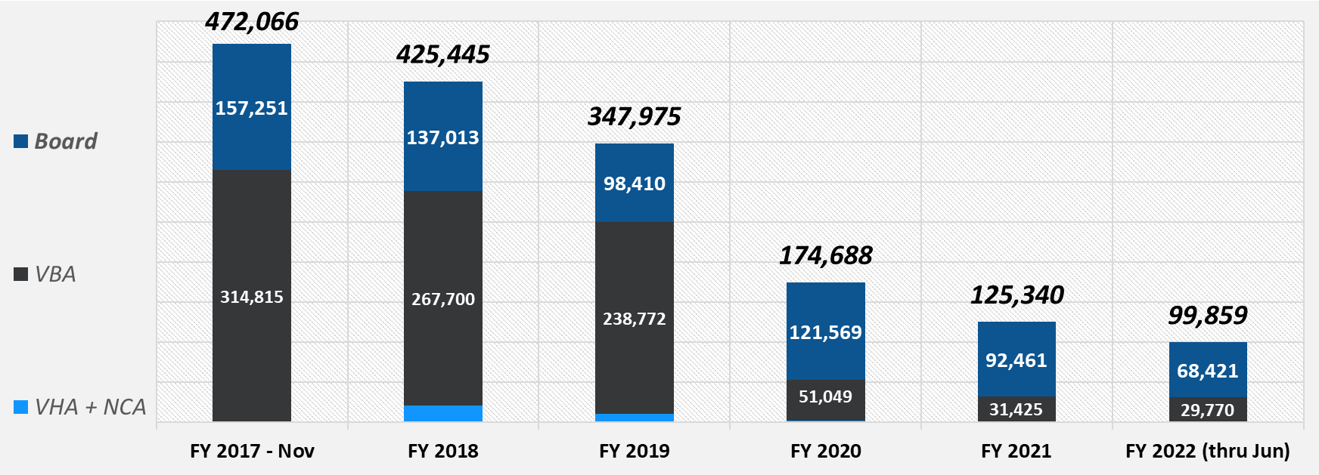
77% reduction in appeals pending since the end of CY 2017

Hearings Held – increased access
The Board increased the number of veteran-requested hearings held – setting a record for the second year in a row. Modernizing hearings through the introduction of Virtual Tele-hearings (during COVID) enabled the Board to double its hearing capacity and hold more hearings than ever before. Once the veteran’s hearing is held, the Board can move the appeal onto the docket for decision.
- As of July 17, 2022, the Board has held 25,106 hearings, 85% were Virtual Tele-hearings.
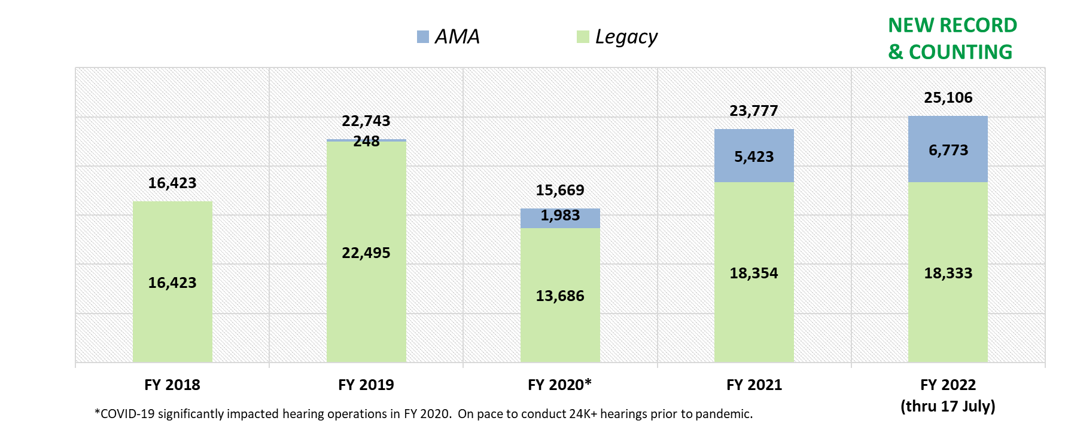
Appeals Decided – improved outcomes
In 5 years, the Board nearly doubled the number of decisions issued for Veterans to approximately 95,000/year and has sustained that level of output for the 3 years and counting. We are on track for FY2022.
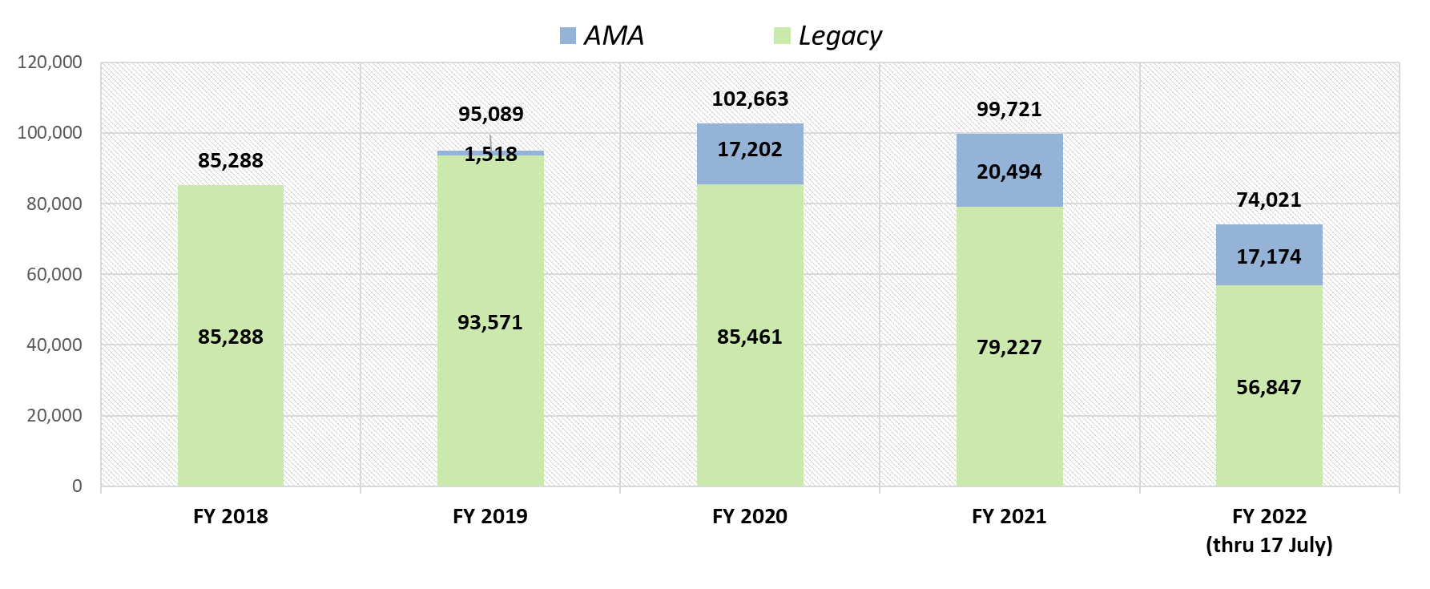

Technology Modernization – Increasing Access
- Electronic Filing – Veterans can now file their appeals with the Board online at va.gov.
- Virtual Tele-Hearings – brings Veterans Law Judges and representatives directly to the veteran via cellphone or laptop. Travel is no longer required – this gives Veterans increased choice and control of their hearing process.
- Veterans can check the status of their claims and appeals on va.gov.

Appeals Modernization Act (AMA)
- The Department implemented the AMA in February 2019, listening and working with stakeholders and representatives to give Veterans’ choice, control and clarity in the claims and appeal processes. While VBA is primarily working claims in AMA, the Board is working both Legacy and AMA appeals based on docket rules set forth by law.

Internal Operations
- The Board recruited and hired the most diverse staff in Board history reflecting those we serve
- 55 new Veterans Law Judges have been appointed in the past 4 years along with additional staff.

All of this transformed the way the Board operates today, both internally and externally, leading to better employee engagement and work-life balance and improving outcomes for our Veterans, families, caregivers, and survivors.
For more info, check out the updated Board website – bva.va.gov

